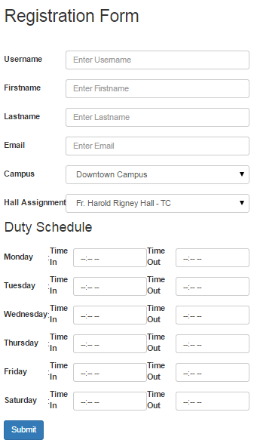

1. Username Text Field

* Description: This is where the Staff registers the working student’s username.
* Action: Staff inputs username

1. Firstname Text Field
   * Description: This is where the staff inputs the working student’s first name.
   * Action: Staff inputs first name
2. Lastname Text Field
   * Description: This is where the staff inputs the working student’s last name.
   * Action: Staff inputs last name
3. E-mail Text Field
   * Description: This is where the staff inputs the working student’s email address.
   * Action: Staff inputs email address.
4. Campus Dropdown Button
   * Description: This is where the staff selects the working student’s campus.
   * Action: Staff selects the campus.
5. Hall Assignment Dropdown Button
   * Description: This is where the Staff chooses the hall assignment of the working student.
   * Action: Staff selects the hall.
6. Time Start Time Field and Time End Time Field per day
   * Description: This is where the Staff assigns the time start and end time of the working student’s duty schedule per day.
   * Action: Staff inputs the Start time and end time of the working student’s duty schedule per day.
7. Submit Button
   * Description: This is where the Staff clicks when done registering the working student.
   * Action: On click, the information will be saved in the database and will prompt that it is successfully registered.